**What is the purpose of Decomposition???**  
In-order to convert a relation from one normal form to another, we have to decompose(i.e divide) that relation into multiple relations.

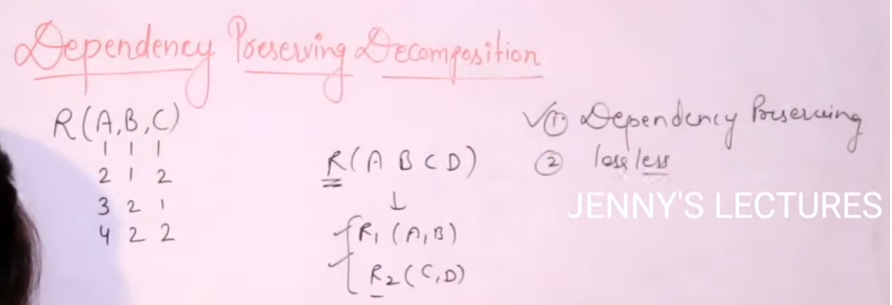

We cannot directly decompose(divide) the relations.

**Dependency Preserving Decomposition**

Dependency preserving is not mandatory property for decomposition.  
But Loseless decomposition is mandatory property for decomposition.

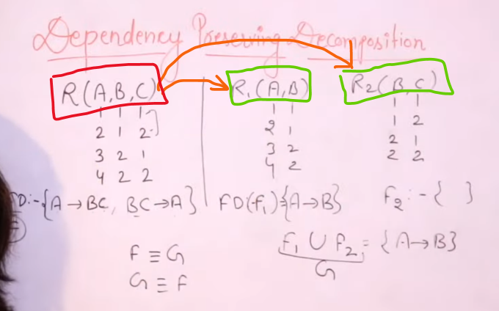

Both G and F should be equivalent, If not then the dependency is not achieved.   
If G and F are equivalent, then dependency is achieved.

The dependency set of the original relation are not being preserved after decomposition the original relation 🡪 Not a Dependency preserving decomposition

Every FD(G) should be the member of FD(F) and Then F and G are  
Every FD(F) should be the member of FD(G) equivalent



Then the function 🡪 Dependency preserving

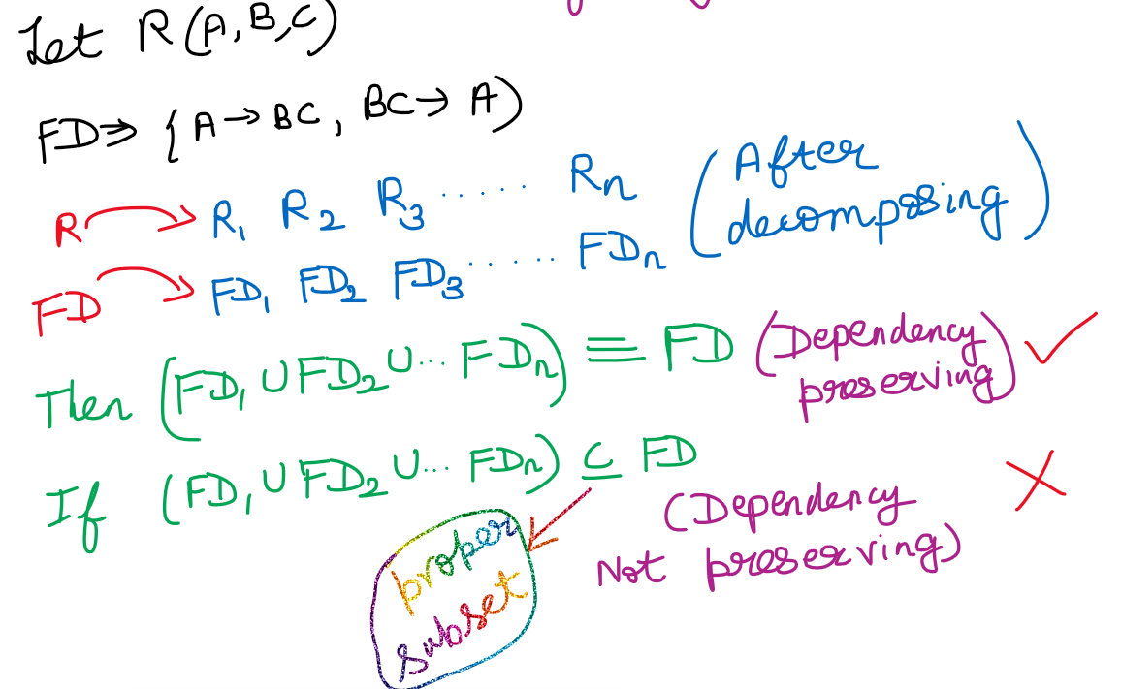



In BCNF we cannot achieve dependency preserving decomposition. But in 1st 2nd 3rd normal form, we can definitely achieve dependency preserving decomposition.

Check whether the relation is Dependency preserving/not

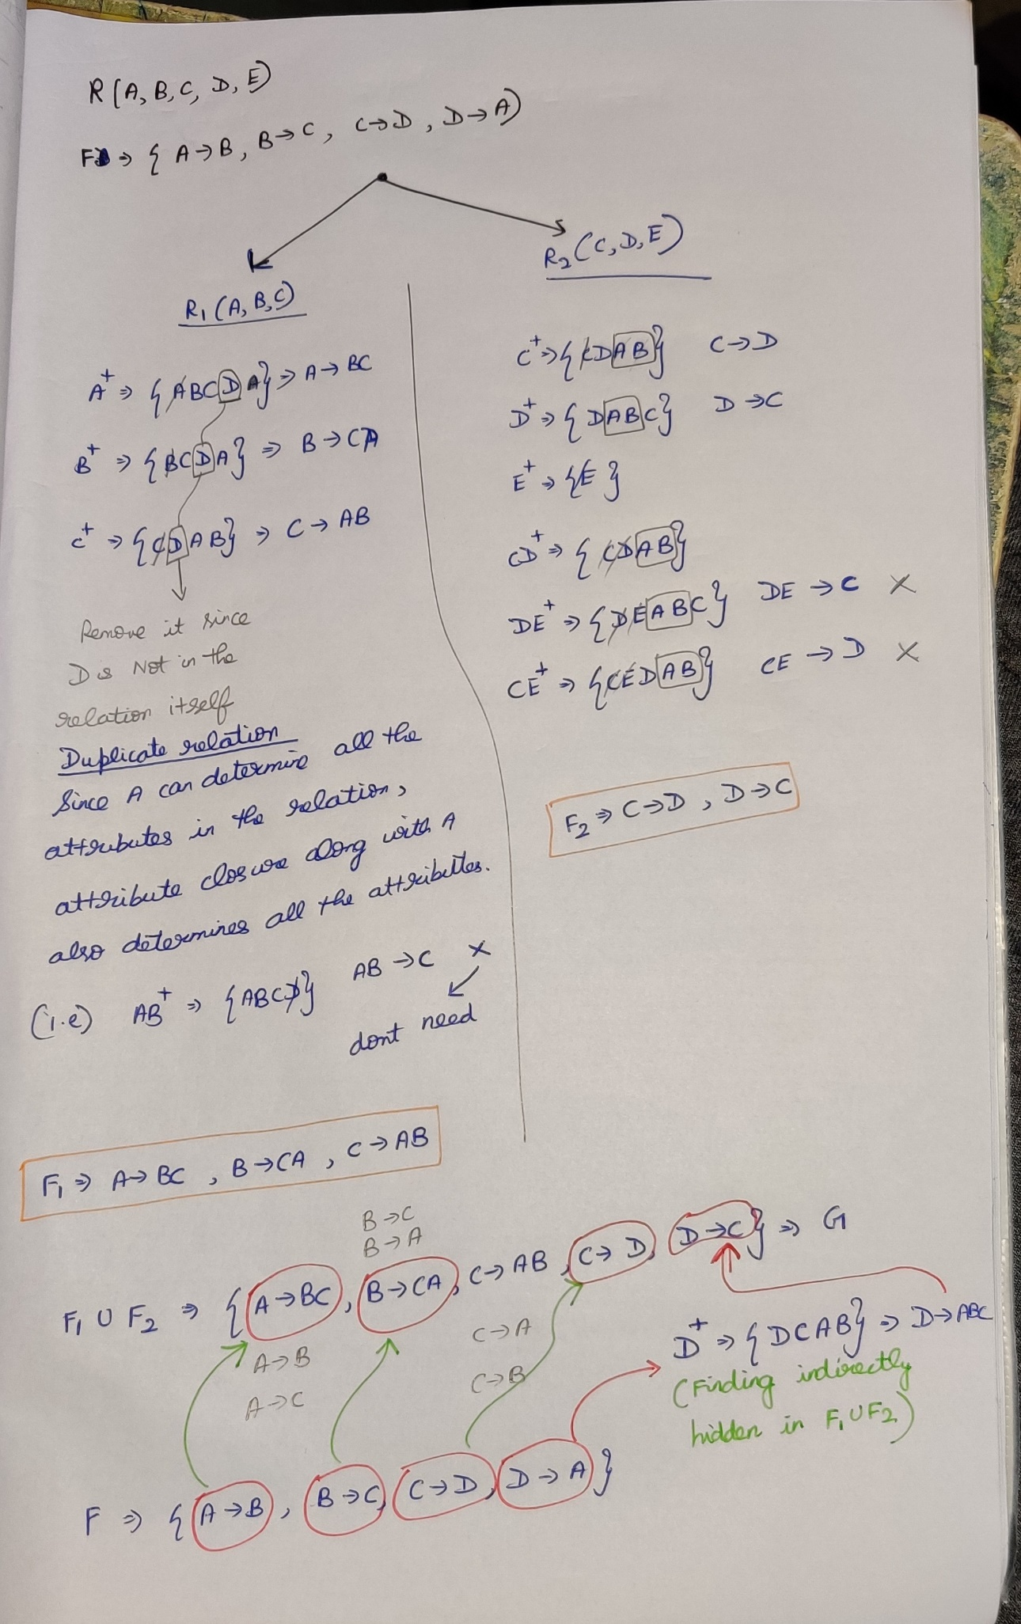



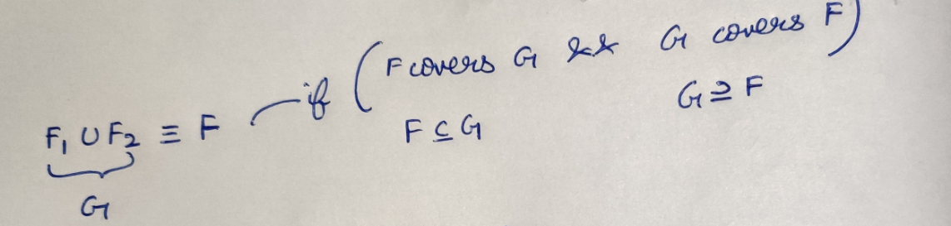  
Therefore the relation is dependency preserving.

Check G covers F, is it covering then definitely 🡪 dependency preserving decomposition. F covers G not necessary since, G is obtained only from F

Definitely because (F1 **U** F2), i.e **G** is derived from F

Only BCNF decomposition will not be dependency preserving but upto 3rd Normal form dependency preserving can be achieved.

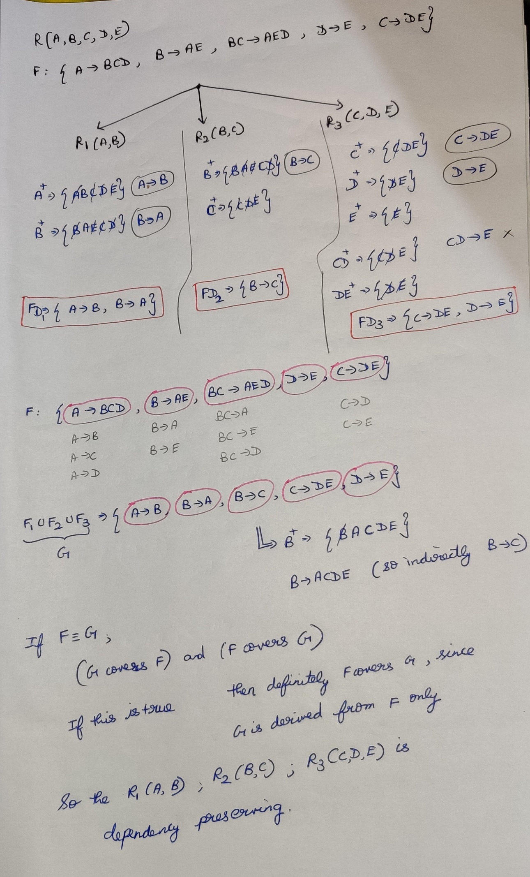



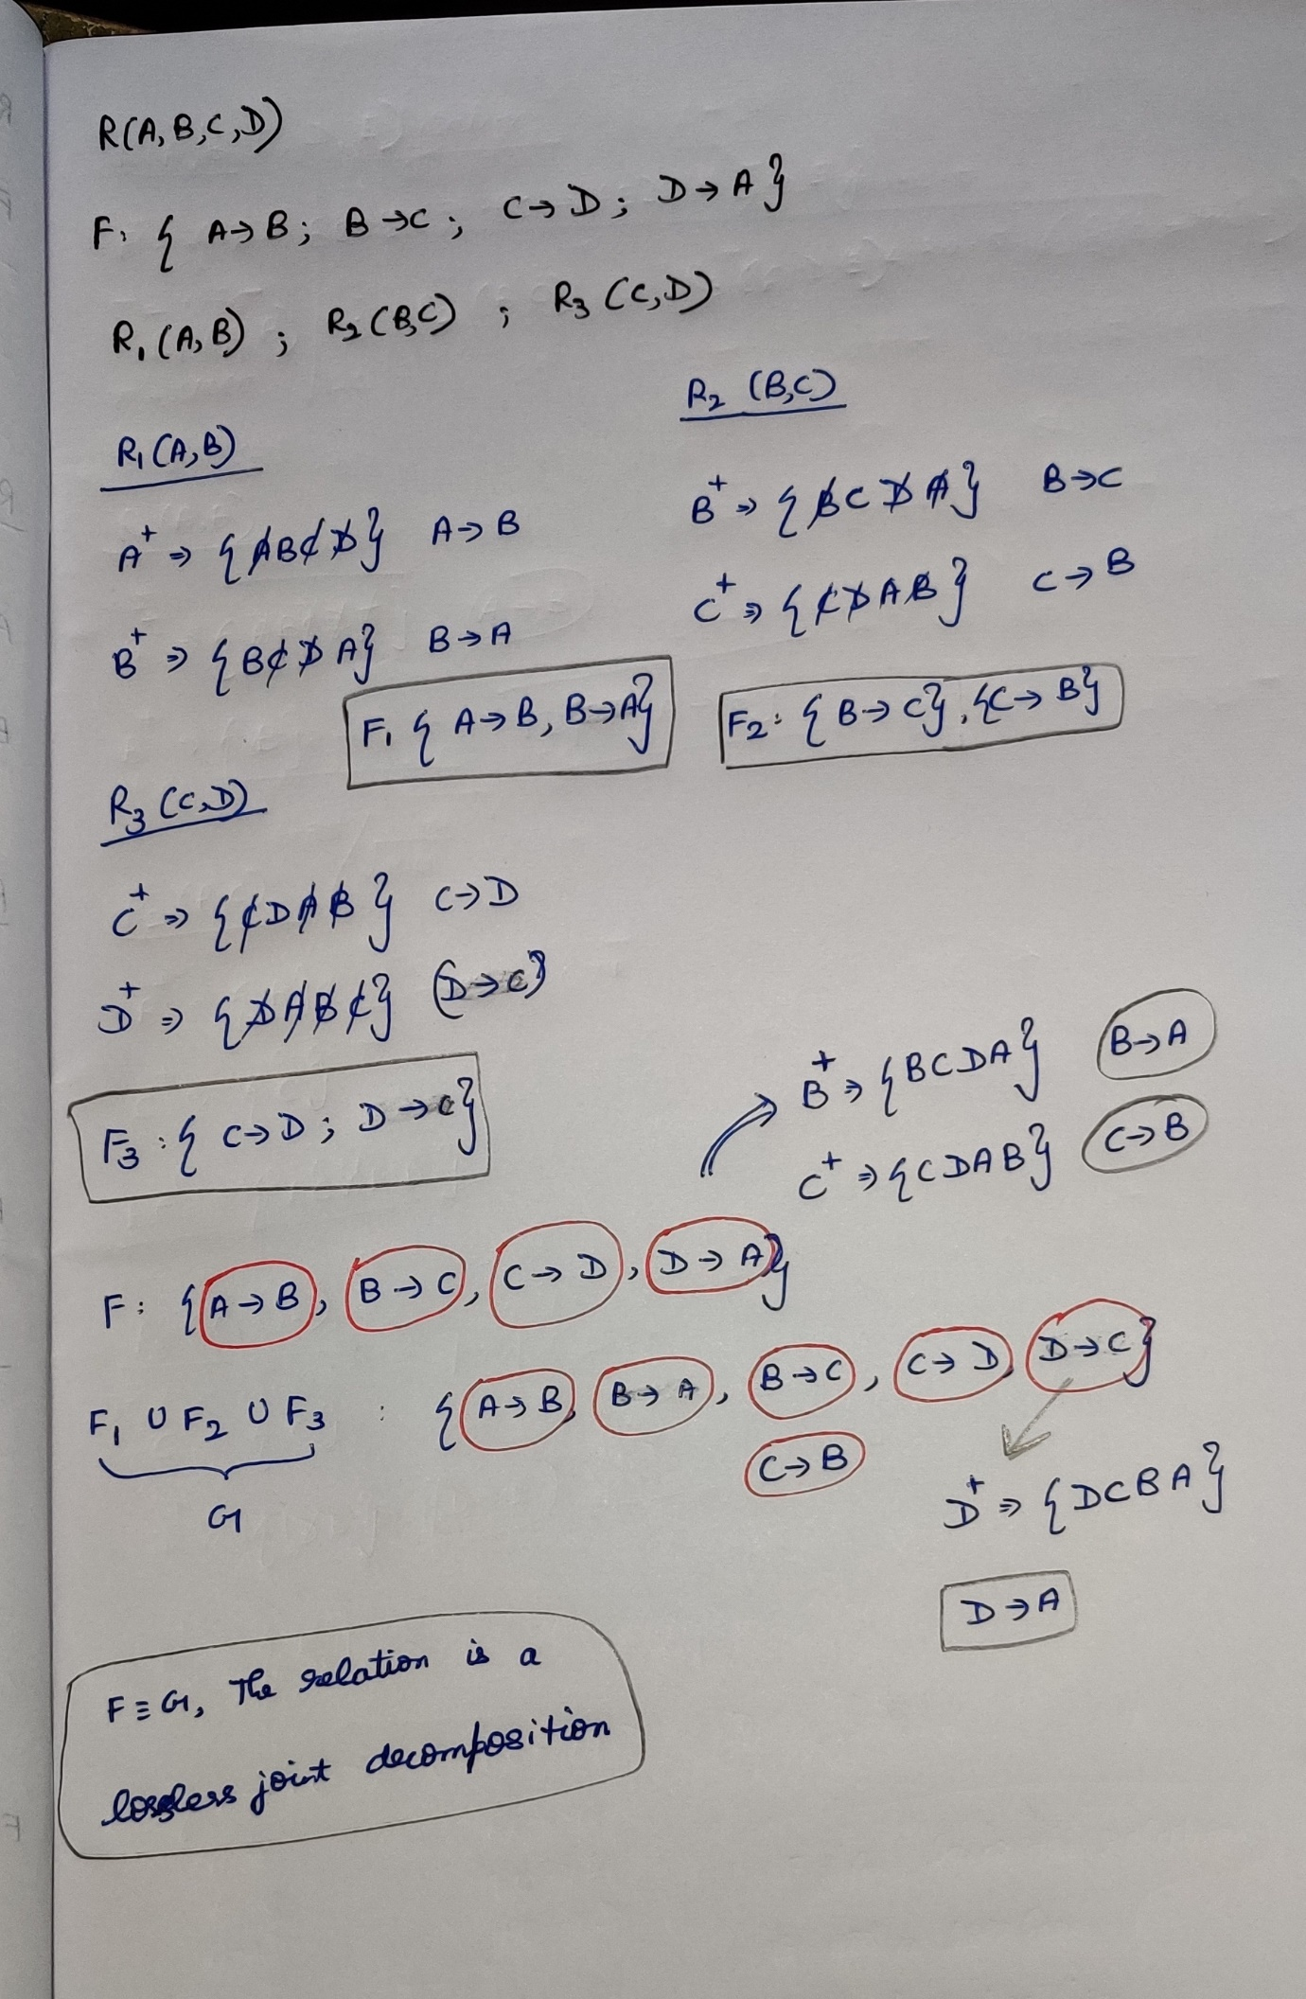



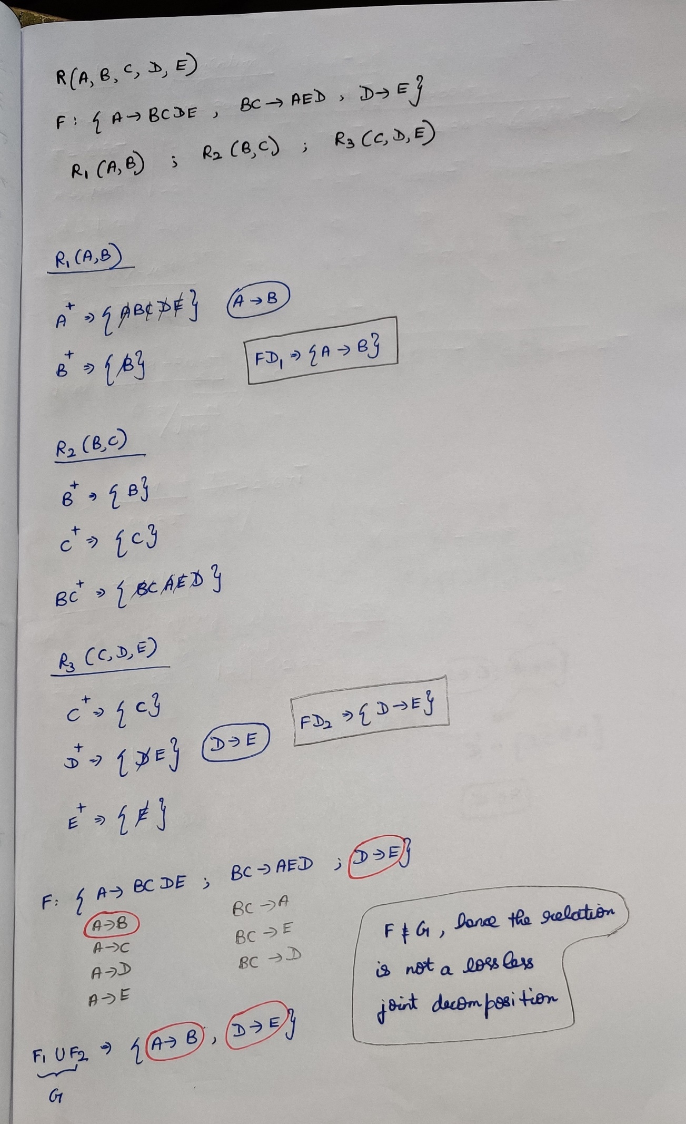



**Lossless Joint Decomposition**

The decomposition of a relation **R** is said to be lossless joint decomposition if it is possible to reconstruct the relation R from decomposed sub relations R1 and R2 using joints.

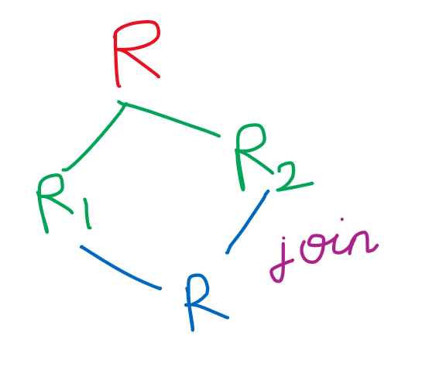

Rules:  
1)The union of attributes of the decomposed relation must be the attribute of the original relation.  
attribute(R1) **union** attribute(R2) = attribute(R)

2)There must be at-least 1 common attribute.  
attribute(R1) **intersection** attribute(R2) != NULL.

3)The common attribute must be super key/candidate key of any-one sub relation.

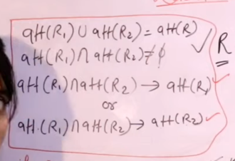

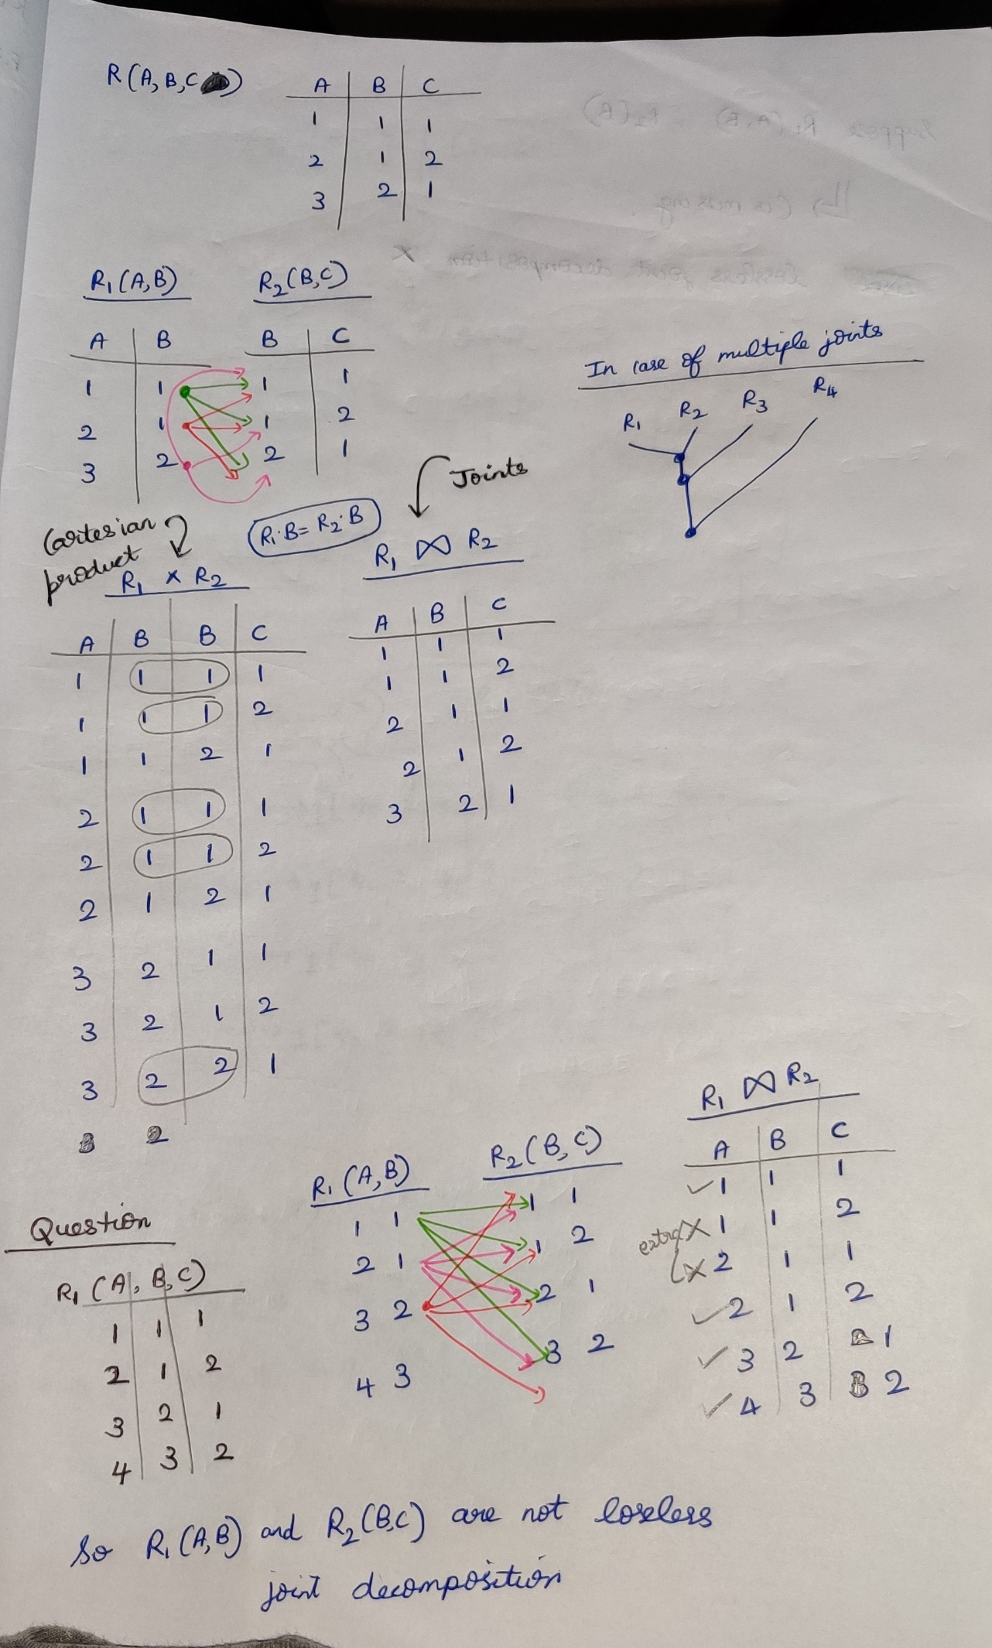

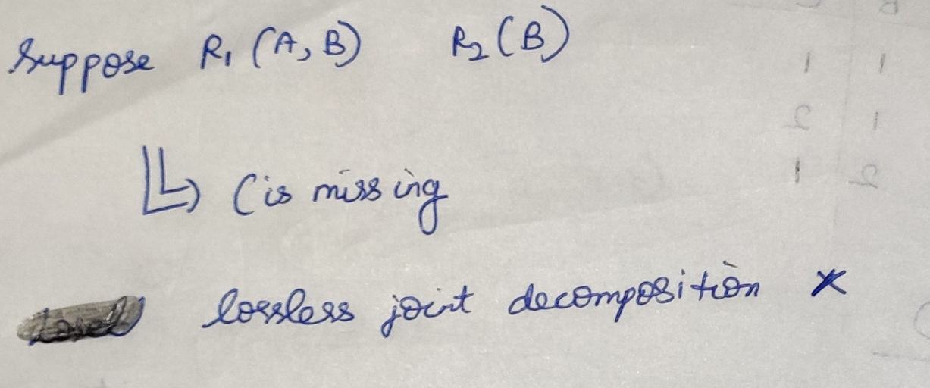  
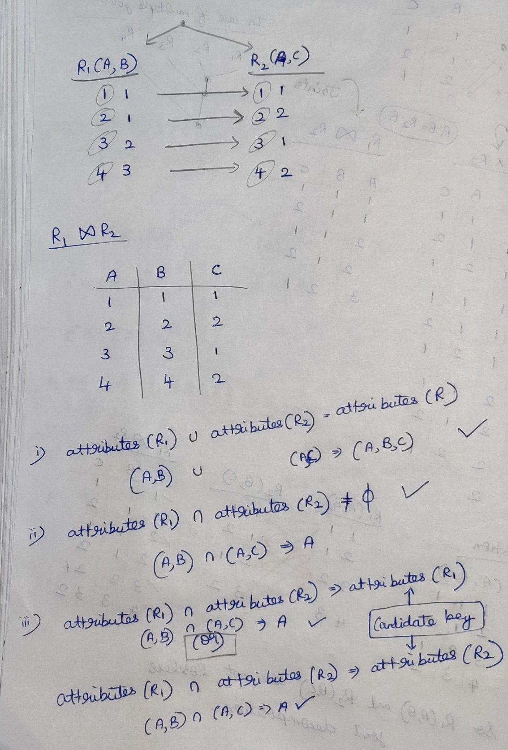



**Explanation for the 3rd point**  
If the common attribute is a candidate key for at-least one sub relation, then definitely that relation is lossless joint decomposition.

By seeing the question, B is not a candidate key but after decomposing the relation, in R2(B,C) the candidate key is B. So definitely that R(A,B,C) is a lossless joint decomposition.

